
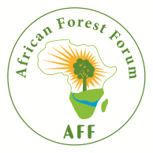
African Forest Forum
A platform for stakeholders in Forestry
A

AFF-HAFL Scholarship Programme Application Form

First name Last name
Birthdate Gender
Citizenship

Contact information
Street address
City Zip code
Country
Email address Skype name (if available)
Phone number

Language proficiency
English French Other Other

Secondary education
Year of graduation University name Degree program Degree

References (please provide reference persons)

Please rank your preferences for the three scholarship study topics
- Vulnerability to climate change and application of promising adaptation measures pertinent to AFOLU
- Policies and practices that integrate mitigation and adaptation in AFOLU
- Private sector in African forestry to address climate change challenges
- Resilience of social, economic, cultural and biological systems to climate change

Attachments
- Letter of motivation for MSc studies
- Draft of research idea
- Short Curriculum Vitae (max. 2 pages)
- Copy of BSc degree or higher
- Copy of respective Transcript of Records (document giving the marks for each course taken)
- Copy of passport (can be completed at a later date)
- Working certificate(s) (at least of one job held for 6 months or more)

