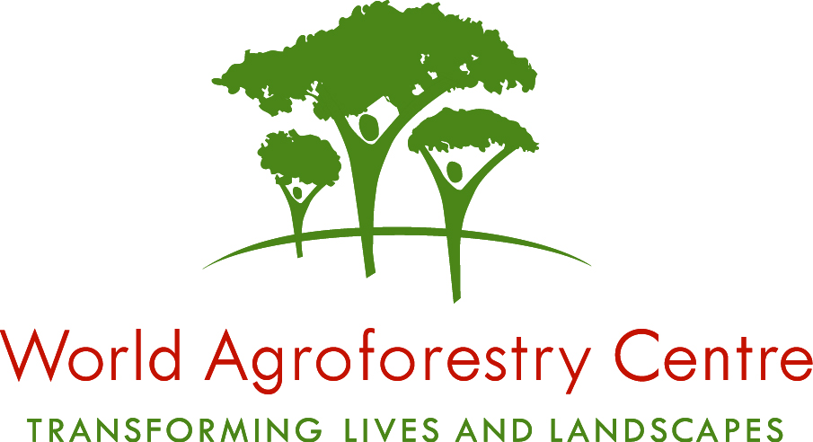

VACANCY: Science Writer/Editor - CIMMYT

CIMMYT is an internationally funded, non-profit research and training organization affiliated with the Consultative Group on International Agricultural Research (CGIAR). The center works to sustainably increase the productivity of maize and wheat farming systems, thus helping to ensure global food security and to reduce poverty. Its partners include national agricultural research systems, non-governmental organizations, and advanced research institutions, both public and private, in globally-focused projects and programs. CIMMYT employs about 600 permanent staff and operates through decentralized partnerships, with offices in 13 developing countries and projects and networks in many more. In Kenya, CIMMYT is hosted by the World Agroforestry Centre (ICRAF) in Nairobi.

The Position

CIMMYT seeks a talented, dedicated Science Writer/Editor to help reach external audiences with pertinent technical and general information about its research maize, wheat, socioeconomics, and conservation agriculture, with special focus on sub-Saharan Africa. The Science Writer/Editor will be based at CIMMYT's office in Nairobi, Kenya.

Responsibilities

The Science Writer/Editor will edit technical scientific publications, grant proposals, and other technical information; and write and edit non-technical material intended to increase public awareness of CIMMYT’s activities, as required.

The specific responsibilities include:
- Help develop diverse communications products, including the corporate annual report, project brochures, funding proposals, policy briefs, technical bulletins, scientific books and chapters, journal- and magazine articles, and varied content for web pages.
- Edit scientific articles, technical reports, and other documents for accuracy, clarity, style, and usage.
- Identify high interest stories throughout the Centre’s research programs and write and/or edit stories in a range of styles for dissemination in suitable formats and to various target audiences.
- Participate in communications planning and strategy development.
- Support and guide media outreach.
- Support and guide extension communications.
- As required, travel to document CIMMYT's work on the ground, including field visits and taking still and video photography.
- Assist scientists in preparing scientific posters, presentations, and other materials.
- Select and provide photographs for use in publications and presentations.
- Assist in preparing presentations for scientific conferences and meetings.

Qualifications and Experience
- Minimum a BA or BSc in communications, journalism, literature, science, agriculture, or another relevant field, and preferably 4-5 years of work experience relating to the position.
- Strong, proven skills in English writing and grammar.
- Fluency in English and Kiswahili; working knowledge of French and/or Spanish desirable.
- A capacity to understand processes and issues related to science and technology; with a focus on issues affecting agriculture and development in sub-Saharan Africa.
- Ability to write/edit under pressure, with high accuracy and to deadline.
- Creativity, particularly in devising new approaches to publications content.
- Ability to work in a team of professionals from many countries and cultures.
- Willingness to travel within the region and, occasionally, internationally.
Terms of offer

The World Agroforestry Centre and CIMMYT are equal opportunity employers and offer a collegial and gender-sensitive working environment. We believe that staff diversity promotes excellence and strongly encourage applications from qualified women. This position is on local terms and will be for an initial period of one (1) year, renewable subject to three (3) months’ probation period, assessment of performance, continued relevance of the position and availability of resources.

How to apply
Applications for the position must include:
- A cover letter illustrating your suitability for the position against the listed requirements and salary expectations.
- A detailed curriculum vitae.
- Two writing samples (preferably formally published).
- The names and addresses of three referees, including telephone, fax numbers and email addresses.

All correspondence should be addressed to the Human Resources Unit, World Agroforestry Centre (ICRAF), PO Box 30677, Nairobi, Kenya OR via email: icrafhru@cgiar.org and should indicate “Application for a Science Writer/Editor-CIMMYT” on their application letters and email submissions.

Applications will be considered through 23rd May 2011: Please note that only short-listed applicants meeting the above requirements will be contacted.

To learn more about our organizations, please visit our website: www.worldagroforestry.org; http://www.cimmyt.org

